Hart County Board of Commissioners
August 26, 2014
5:30 p.m.

- PRAYER

- PLEDGE OF ALLEGIANCE

- CALL TO ORDER

- WELCOME

- APPROVE AGENDA

- APPROVE MINUTES OF PREVIOUS MEETING(S)
- 8/12/14 Regular Meeting
- 8/12/14 Called Budget Meeting
- 8/20/14 HCHA Subcommittee Meeting

- REMARKS BY INVITED GUESTS, COMMITTEES, AUTHORITIES

- REPORTS BY CONSTITUTIONAL OFFICERS & DEPARTMENT HEADS

- COUNTY ADMINISTRATOR’S REPORT

- CHAIRMAN’S REPORT

- COMMISSIONERS’ REPORTS

- OLD BUSINESS
- Hart County Hospital Authority Resolution- Joint Meeting with Hart County HA

- NEW BUSINESS
- Jerry Hanneken- “Sky Latterns” Fire Hazard

- PUBLIC COMMENT

- EXECUTIVE SESSION-Real Estate, Litigation

- ADJOURNMENT

Hart County Board of Commissioners
August 26, 2014
5:30 p.m.

The Hart County Board of Commissioners met August 26, 2014 at 5:30 p.m. at the Hart County Administrative & Emergency Services Center.

Chairman Joey Dorsey presided with Commissioners R C Oglesby, Frankie Teasley, Jimmy Carey and William Myers in attendance.

- Prayer
Prayer was offered by Rev. Brad Goss.

- Pledge of Allegiance
Everyone stood in observance of the Pledge of Allegiance.

- Call to Order
Chairman Dorsey called the meeting to order.

- Welcome
Chairman Dorsey welcomed those in attendance.

- Approve Agenda
Commissioner Oglesby moved to amend and approve the agenda to include item 13b) MOU/Board of Education. Commissioner Myers provided a second to the motion. The motion carried 5-0.

- Approve Minutes of Previous Meeting(s)
- 8/12/14 Regular Meeting
- 8/12/14 Called Budget Meeting
- 8/20/14 HCHA Subcommittee Meeting
Commissioner Carey moved to approve the minutes of August 12 and August 20, 2014 as amended. Commissioner Teasley provided a second to the motion. The motion carried 5-0.

- Remarks By Invited Guests, Committees, Authorities
None

- Reports by Constitutional Officers & Department Heads
None

- County Administrator’s Report
County Administrator Jon Caime did not have anything to report.

- Chairman’s Report
Chairman Joey Dorsey did not have anything to report.

- Commissioners’ Reports
Commissioner Teasley reported that Whitworth Parole Center is continuing to provide details to pick up trash along the county road right-of-ways; he received an inquiry from Beth Howell concerning the property that was utilized by the fire department at Reed Creek. County Attorney Walter Gordon responded that is a right of reversion clause in the deed however, he suggested discussing real estate in executive session.

Commissioner Myers reported that the railroad department is making road repairs on Bowersville Road near the seed plant.

- Old Business
- Hart County Hospital Authority Resolution-Joint Meeting with Hart County HA
Commissioner Carey moved to enter into the joint meeting with the Hospital Authority. Commissioner Teasley provided a second to the motion. The motion carried 5-0.

HA Chairman Tony Hilton called their meeting to order.

County Attorney Walter Gordon stated that he is not aware of any other issues that have not been discussed with the subcommittee.

Commissioner Myers moved to approve the Joint Resolution for the dissolution of the Hospital Authority. Commissioner Teasley provided a second to the motion. The motion carried 5-0.

Chairman Dorsey thanked HA members for their service to the community.

Tony Hilton recognized the current authority members and thanked everyone that has served over the past forty seven years.

Commissioner Carey moved to close the joint meeting. Commissioner Myers provided a second to the motion. The motion carried 5-0.

The regular meeting convened.

- New Business
- Jerry Hanneken “Sky Lanterns” Fire Hazard
Mr. Hanneken reported that he recently found a sky lantern on his property and voiced his concern over the lanterns causing a fire hazard.

Commissioner Dorsey reported that the Fire Department was called out to a fire as the result of a Japanese lantern and fireworks.

No action was taken.

- MOU – Board of Education
Commissioner Oglesby moved to authorize Chairman Dorsey to execute the documents on behalf of the BOC for the application of a grant for the BOE. Commissioner Myers provided a second to the motion. The motion carried 5-0.

- Public Comment
Tom Hardigree commented on providing tax incentives for buyers of lake lots.

- Executive Session – Real Estate, Litigation
Commissioner Oglesby moved to exit into executive session to discuss real estate and litigation matters. Commissioner Myers provided a second to the motion. The motion carried 5-0.

With no further action taken during Executive Session, Commissioner Oglesby moved to exit. Commissioner Myers provided a second to the motion. The motion carried 5-0.

In the regular meeting, Commissioner Oglesby moved to authorize County Attorney Gordon to execute the right of reversion for the former Reed Creek Fire Station. Commissioner Myers provided a second to the motion. The motion carried 5-0.

- Adjournment
Commissioner Carey moved to adjourn the meeting. Commissioner Teasley provided a second to the motion. The motion carried 5-0.

-------------------------------------------------------------- ----------------------------------------------------------
Joey Dorsey, Chairman Lawana Kahn, County Clerk

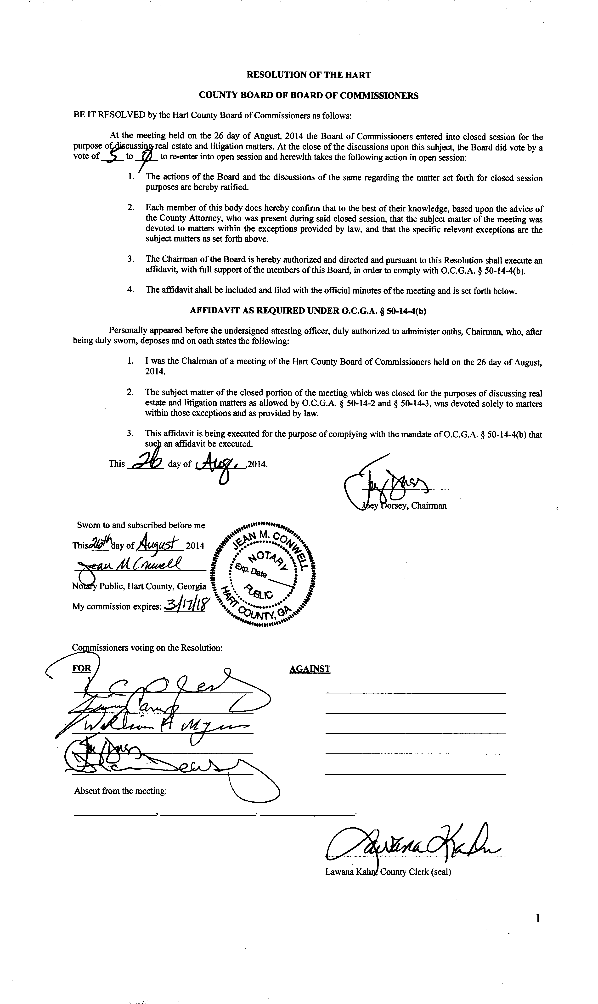

Subcommittee of the Hart County Board of Commissioners
Hart County Hospital Authority Joint Resolution
Meeting Minutes
August 20, 2014
5:30 p.m.

- Joint Resolution
Present: Chairman Joey Dorsey, Commissioner Frankie Teasley, HCHA Tony Hilton and David Thompson, HCHA Attorney Bob Ridgeway, County Attorney Walter Gordon, County Administrator Jon Caime.

A discussion ensued about the closing documents for the dissolution of the HCHA and the subsequent transfer of responsibilities to the HCBOC.

-------------------------------------------------------------- -----------------------------------------------------------
Joey Dorsey, Chairman Lawana Kahn, County Clerk

Hart County Board of Commissioners
Called Meeting
August 26, 2014
After the 5:30 p.m. Regular BOC Meeting

Called Meeting:
FY15 Budget:
- Approval of SW Contract
- 13000 BOC
- 10000 General Government
- 22000 District Attorney
- 24500 Probate Court
- 26000 Juvenile Court
- 27000 Grand Jury
- 27500 Law Library
- 28100 Board of Equalization
- 37000 Coroner
- 39100 Animal Control
- 55200 Senior Center
- 55400 Transit
- 65100 Library
- 71300 Ag Resources
- 75630 Airport
- 76300 Community Action
- 76400 Literacy Center
- 206 Beh Health SRF
- 216 DFACs Building SRF
- 251, 253, 254, 255, 256 EIP SRF
- 220 Multiple Grants SRF
- 322 SP2
- 323 SPLOST3
- 324 SPLOST4
- GF Revs
- Other Items As Time Allows

Already Discussed:
14000 Elections,14100 BOR, 14200 Board of Elections, 15450 Tax Commissioner, 15300 Law, 15500 BOA, 15550 Risk Management, 15600 Internal Audit, 15650 General Government- Buildings, 15950 General Administration Fees, 21500 Superior Court, 21800 Clerk of Court, 24000 Magistrate Court, 28000 Public Defender, 33000 Sheriff, 33260 Jail, 34200 Adult Corrections, 36000 EMS, 39200 EMA, 42000 Roads (203 & GF), 49000 Maintenance Shop, 51000 Health Dept, 54000 DFACs, 61000 Recreation, 75000 Econ Dev., 201 DARE SRF, 203 Fund Fire, 204 Jail Fund SRF, 215 Fund 911 Operations, 203 Other Fund Budgets- (Not fire or roads), 540 Fund Solid Waste

Hart County Board of Commissioners
August 26, 2014
Called Meeting
5:30 p.m.

The Hart County Board of Commissioners met August 26, 2014 at the Hart County Administrative Building after the regularly scheduled BOC meeting.

Chairman Joey Dorsey presided with Commissioners Frankie Teasley, Jimmy Carey, R C Oglesby and William Myers in attendance.

The BOC discussed the following budgets: 13000 BOC, 10000 General Government, 22000 District Attorney, 24500 Probate Court, 26000 Juvenile Court, 27000 Grand Jury, 27500 Law Library, 28100 Board of Equalization, 37000 Coroner, 39100 Animal Control, 55200 Senior Center, 55400 Transit, 65100 Library, 71300 Ag Resources, 75630 Airport, 76300 Community Action, 76400 Literacy Center, 206 Beh Health SRF, 216 DFACs Building SRF, 251, 253, 254, 255, 256 EIP SRF, 220 Multiple Grants SRF, 322 SP2, 323 SPLOST3, 324 SPLOST4, GF Revs

A discussion with the District Attorney about space needs took place. The BOC agreed the optimal location for the DA would be in the space currently occupied by the Tax Commissioners Office and that the Tax Commissioners Office should be located at the Cade Street Office Building.

The BOC also heard a request from the HYDRA program which was defunded by the BOC in 2012.

Commissioner Oglesby made a motion to approve the solid waste contract. Chairman Dorsey provided a second to the motion and the motion passed 5-0. Due to the fact that the bag fees for solid waste have not increased for at least 15 years, the BOC also agreed to raise the bag fees by $0.25 for small bags ($0.75) and $0.50 for large bags ($1.50).

Commissioner Myers made a motion to adjourn, Commissioner Carey provided a second to the motion and the motion passed 5-0.

-------------------------------------------------------- ---------------------------------------------
Joey Dorsey, Chairman Lawana Kahn, County Clerk

